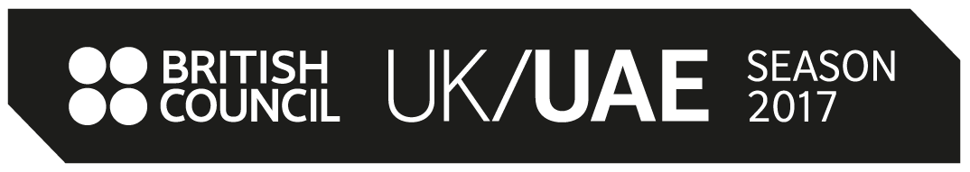

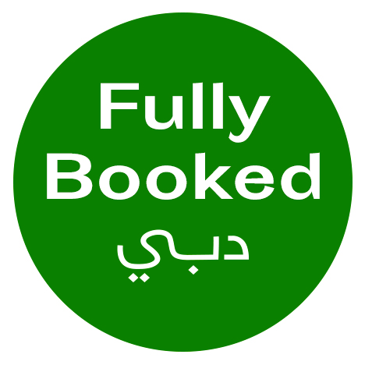

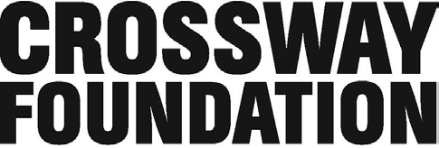

***DUBAI’S FIRST ART BOOK FAIR***

AS PART OF UK/UAE 2017, THE CROSSWAY FOUNDATION & THE BRITISH COUNCIL CELEBRATE 15 YEARS OF CROSS-CULTURAL JOURNEYS THROUGH PARTNERSHIP WITH FULLY BOOKED, DUBAI'S FIRST AND ONLY ART BOOK FAIR

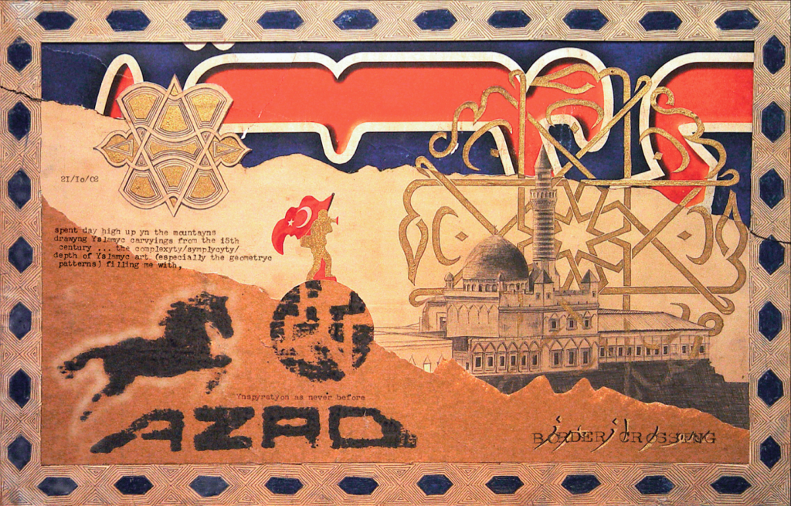

15 years ago a group of British artists embarked on a life-changing journey across a post-9/11 Middle East, travelling in a converted Toyota pick-up truck through Turkey, Iran, Iraq, the UAE, Oman, Yemen, Saudi Arabia, Jordan, Syria, Egypt, Israel and Palestine... they called the project, ‘Offscreen’.

With the support of the British Council, Offscreen developed into an award-winning book and education programme, which inspired the establishment of the Crossway Foundation, a UK charity delivering arts education initiatives for young people between the UK and the Middle East.

To mark 15 years since the original Offscreen artists’ journey, and 10 years since the Crossway Foundation’s first youth expedition (from the UK to the UAE and Oman), the Crossway Foundation has partnered with the United Arab Emirates’ first and only Art Book Fair, Fully Booked.

The fair will serve as a platform to consider the medium of the artist book as a “multi-site”—a tactile, portable, and accessible form. This form allows for the creative and democratic dissemination of information across borders, while simultaneously enabling intimacy with content. The intention of the fair is to foster meaningful cultural exchanges between regional and international artist, designers and publishers, as well as the cultural practitioners and visitors present in Dubai during Art Week.

**Programming for the fair is being presented by the UK-based Crossway Foundation in association with The British Council as part of the UK/UAE 2017 Year of Creative Collaboration. A 'Border Crossing' programme including an artwork exhibition, film screenings, workshops and talks, will focus on the intersection of art, travel and cultural exchange with a special focus on collaborations between the UK and UAE.**

“We are delighted to partner with Crossway Foundation on Fully Booked, the first and only art book fair in Dubai. This is a fitting project to celebrate 15 years of Crossway Foundation’s work on arts and education initiatives for young people in the Middle East and the UK. The UK/UAE 2017 Year of Creative Collaboration is a celebration of the UK and UAE’s longstanding relationship, bringing to light its contemporary relevance and discovering new ways of connecting with and understanding each other through culture. The fair and the Border Crossing programme will serve as a platform to foster meaningful cultural exchange between regional and international artists, designers and publishers, as well as cultural practitioners and visitors, and will make a significant contribution to UK/UAE 2017 programme.” **Gavin Anderson, Country Director, the British Council.**

The fair will be hosted in Warehouse i-82, a purpose-built 325 square meter warehouse in Alserkal Avenue, the region’s foremost arts hub.

**Fully Booked will be open as a fair from March 13–18th, 2017, with the opening night on 13th March.** The fair coincides with Dubai Art Week and the openings of the eleventh edition of the Art Dubai fair and the thirteenth Sharjah Biennial. **The art book exhibition, co-curated by the Crossway Foundation and Fully Booked’s directors, will be held in the same warehouse space and will continue (without vendors) from March 19–27th.**

**Participating UAE And UK artists (subject to change) include:**

Georgie Weedon (UK)

Lujain Abulfaraj (UAE)

Tulip Hazbar (UAE)

Nasser Alzayani (UAE)

Al Braithwaite (UK)

Henry Hemming (UK)

Stephen Stapleton (UK)

Booth-Clibborn Editions (UK)

Sarah Alfarhan (UAE)

Moaza Matar (UAE)

Jaffat El Aqlam (UAE)

Eman AlHashemi (UAE)

Tom Baggaley (UAE)

Eman AlEghfeli (UAE)

Areej Kaoud (UAE)

**Special Focus Artists Books / Artworks / Workshops to include:**

**The Offscreen Collages (UK)**

The first ever display of all 120 collages from the original Offscreen artists journey 2002-2003 (from the award-winning book: *Offscreen, Four Young artists in the Middle East* published by Booth Clibborn Editions in 2004)

**The Road Tapes (UK)**

Video Work of road footage from across the Middle East

By Al Braithewaite

**Zine-Making Workshop with Tulip Hazbar (UAE)**

Date: Thursday 16th March

Time: 12 - 3 PM

Location: Warehouse i-82

Free of Charge

Age Limit: 16+

RSVP: [info@crossway-foundation.org](mailto:info@crossway-foundation.org)

In this workshop, participants will draw inspiration from their surrounding environment, Al Serkal Avenue, and will be asked to collaborate to create fictional scenarios and narratives. These explorations will manifest in the form of a printed zine.

**'Everyone Can Draw": Blind Drawing with Nasser Al Zayani (UAE)**

Date: Saturday 18th March

Time: 12 - 2 PM

Location: Warehouse i-82

Free of Charge

RSVP: [info@crossway-foundation.org](mailto:info@crossway-foundation.org)

When Nasser embarks on any journey, he is always accompanied by his sketchbook. More than a companion, the pages of these sketchbooks hold a record of every place he visits. They serve as a tool of documentation as well as a process of crossing borders, bridging his senses with the world around him. One of the most direct forms of drawing found in his sketchbooks are his blind portraits.

This workshop will attempt to change people’s perceptions of what is considered a ‘beautiful’ drawing. Participants will be teamed up, regardless of their artistic background or skill, and asked to draw their partner. The twist is that they will not be able to look down at their paper.

**FAIR SCHEDULE:**

**13 March, 10:00 – 22:00** The warehouse space opens to the public as an art book fair and exhibition. The opening reception will be 18:00–22:00 that evening. We anticipate the largest crowds on this night.

**14-18 March, 10:00 – 19:00** The fair continues through the weekend.

**19-27 March, 10:00 – 19:00** The space remains open solely as an art book exhibition with normal gallery hours (no vendors.

**For further information, and high res images, please contact** [**info@crossway-foundation.org**](mailto:info@crossway-foundation.org)

**ABOUT THE CROSSWAY FOUNDATION**

The Crossway Foundation is a UK-based charitable foundation delivering arts and education initiatives for young people in the Middle East and the UK. The Foundation focuses on delivering international creative journeys for young people, as well as running a public programme that is free and open to all.

The Crossway Foundation has been delivering life-changing journeys since 2007, working with young artists in Egypt, Jordan, Kuwait, Lebanon, Oman, Saudi Arabia, Qatar, Pakistan, Malaysia, the United Kingdom and the United Arab Emirates.

[www.crossway-foundation.org](http://www.crossway-foundation.org) | [Facebook](https://www.facebook.com/crosswayfoundation) | [Instagram](https://www.instagram.com/crosswayuk/) | [Twitter](http://twitter.com/crosswayuk)

**ABOUT UK/UAE 2017**

UK/UAE 2017 is a year of creative collaboration and cultural exchange between the United Kingdom and the United Arab Emirates, organised by the British Council, the UK’s international organisation for education and culture, under the patronage of HH Sheikh Mohammed bin Zayed Al Nahyan, Crown Prince of Abu Dhabi and Deputy Supreme Commander of the UAE Armed Forces, and HRH The Prince of Wales. The purpose of UK/UAE 2017 is to celebrate the long-standing relationship between the UK and the UAE, giving it greater focus, depth and contemporary relevance. Throughout 2017, the British Council will collaborate with a wide range of British and Emirati partners to create a diverse programme that spans the arts, literature, education, society, sport, science and trade. Through exploring the ways in which our respective cultural heritage and contemporary creative expression inspires innovation in all sectors and all areas of society, UK/UAE 2017 will strengthen cultural and economic ties between the two nations and identify major opportunities for future collaboration on both sides.

To stay up-to-date with the latest news and programme, please visit the British Council’s UAE website: [www.britishcouncil.ae/en/uk-uae-2017](http://www.britishcouncil.ae/en/uk-uae-2017) or follow the social media channels on [Facebook](https://www.facebook.com/BritishCouncilUAE) | [Instagram](https://www.instagram.com/britishcounciluae/) | [Twitter](https://twitter.com/uaeBritish).

**For further information and enquiries, please contact Tuba Tortop at**[**tuba.tortop@ae.britishcouncil.org**](mailto:tuba.tortop@ae.britishcouncil.org)**.**

**ABOUT THE BRITISH COUNCIL**

The British Council is the UK’s international organisation for cultural relations and educational opportunities. We create friendly knowledge and understanding between the people of the UK and other countries. Using the UK’s cultural resources we make a positive contribution to the countries we work with – changing lives by creating opportunities, building connections and engendering trust.

We work with over 100 countries across the world in the fields of arts and culture, English language, education and civil society. Each year we reach over 20 million people face-to-face and more than 500 million people online, via broadcasts and publications.

Founded in 1934, we are a UK charity governed by Royal Charter and a UK public body. The majority of our income is raised delivering a range of projects and contracts in English teaching and examinations, education and development contracts and from partnerships with public and private organisations. Eighteen per cent of our funding is received from the UK government.

**ABOUT FULLY BOOKED**

Fully Booked premieres in 2017 as the only art book fair in the United Arab Emirates. The fair will serve as a platform to consider the medium of the artist book as a “multi-site”— a tactile, portable, and accessible form. This form allows for the creative and democratic dissemination of information, while simultaneously enabling intimacy with content. The intention of the fair is to foster meaningful cultural exchanges between regional and international artist publishers, as well as the cultural practitioners and visitors present in Dubai during Art Week.

[www.fullybooked.ae](http://www.fullybooked.ae) | [Instagram](http://instagram.com/fullybooked.ae/)